**Christopher King**

**2018141521058**

**Mechanical Design 2**

**Class Section 01**

**11/17/2021**

# **Problem 1**

A single-threaded 25-mm power screw is 25 mm in diameter with a pitch of 5 mm. A vertical load on the screw reaches a maximum of 5 kN. The coefficients of friction are 0.06 for the collar and 0.09 for the threads. The frictional diameter of the collar is 45 mm.

1. Find the torque to “raise” and “lower” the load.
2. Find the overall efficiency.

**Solution:**



Single-threaded:



# **Problem 2**

The press shown in figure below has a rated load of 5000 lbf. The twin screws have Acme threads, a diameter of 2 in, and a pitch of 1/4 in. Coefficients of friction are 0.05 for the threads and 0.08 for the collar bearings. Collar diameters are 3.5 in. The gears have an efficiency of 95 percent and a speed ratio of 60:1. A slip clutch, on the motor shaft, prevents overloading. The full-load motor speed is 1720 rev/min.

1. When the motor is turned on, how fast will the press head move?
2. What should be the horsepower rating of the motor?

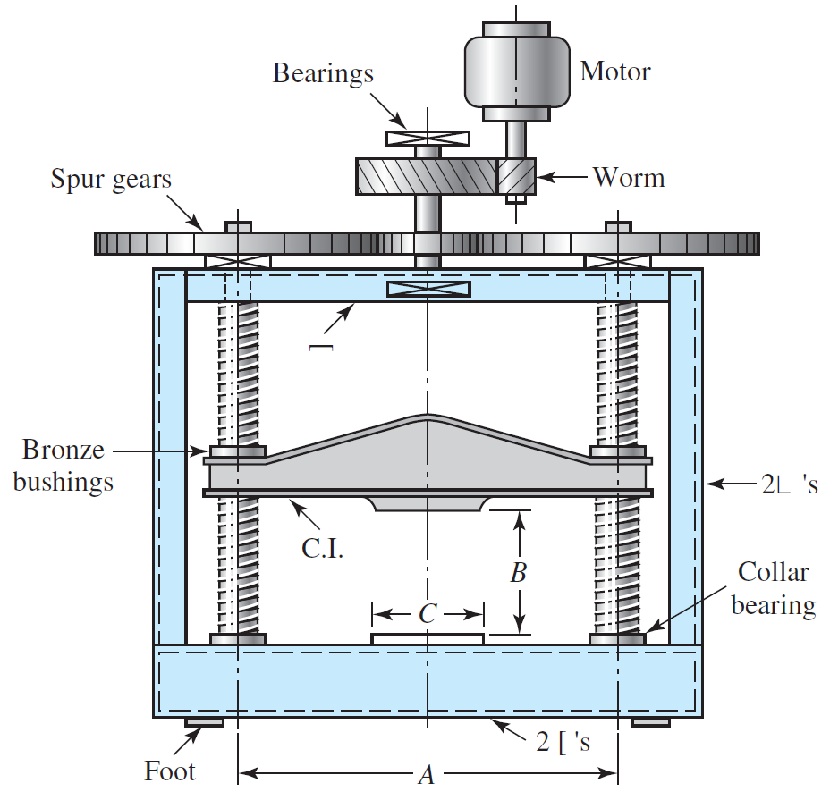

**Solution:**



Single-threaded:

# **Problem 3**

A double square-thread power screw has an input power of 3 kW at a speed of 1 rev/s. The screw has a diameter of 40 mm and a pitch of 8 mm. The frictional coefficients are 0.14 for the threads and 0.09 for the collar, with a collar friction radius of 50 mm. Determine

1. the axial resisting load F and the combined efficiency of the screw and collar;
2. axial stress and torsional stress on thread body;

With calculated F, assume the first-engaged thread takes 40 percent of the axial load, calculate the followings:

1. bearing stress on thread flank;
2. max shear stress across puncture plane of the thread;
3. thread bending stress at the root of the thread;
4. von Mises stress at the root of the thread; and
5. draw a 3D stress element to show the direction of all component stresses acting on element at the root.

**Solution:**

Double-threaded:



Axial stress:

Torsional stress:



Bearing stress:



Max shear stress



Thread bending stress:



von Mises stress: